Cranberry-Bourbon Sippers

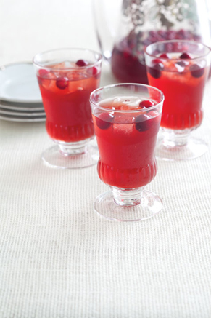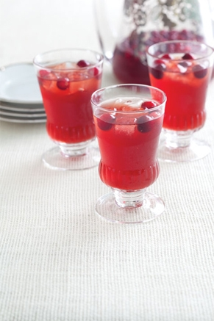
Servings: 7 cups
Difficulty: Easy

Ingredients
2/3 cup water
2/3 cup light brown sugar
4 cups chilled cranberry juice
1 cup chilled pomegranate juice
1/2 cup bourbon
1/2 cup chilled fresh lime juice
1/4 cup chilled fresh lemon juice
Garnish: fresh cranberries

Directions
1. In a medium saucepan, bring 2/3 cups water and brown sugar to a boil over medium-high heat, stirring just until sugar dissolves. Remove from heat, and let cool completely.
2. In a large pitcher, combine sugar mixture, cranberry juice, and remaining 4 ingredients. Serve over ice. Garnish with cranberries, if desired.

Sour Cream Butter Biscuits

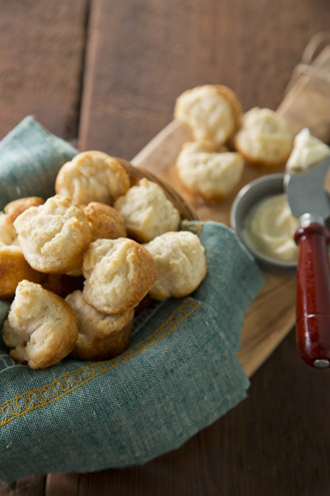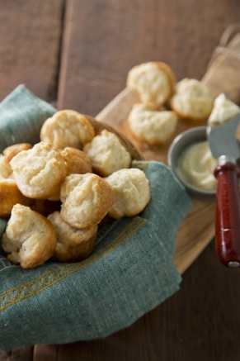

Servings: about 3 dozen miniature biscuits
Prep Time: 15 min
Cook Time: 9 min
Difficulty: Easy

Ingredients
2 cups self-rising flour
1 cup (2 sticks) butter, at room temperature
1 cup sour cream

Directions
Preheat the oven to 400 degrees F. Grease miniature muffin pans.
Mix the flour and butter together, add the sour cream, and blend well. Place spoonfuls of the batter in the muffin pans. Bake until golden, 8 to 10 minutes.

Uncle Bob’s Fresh Apple Cake
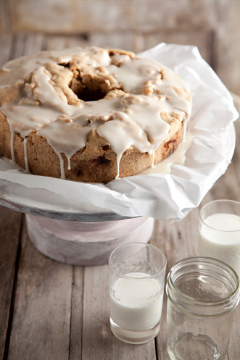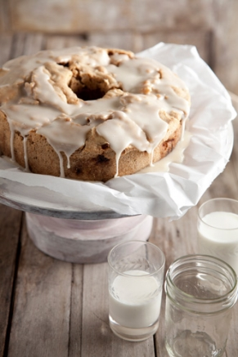
Servings: 6 to 8 servings, about 3/4 cup
Prep Time: 1 hour 25 min
Cook Time: 1 hour 30 min
Difficulty: Easy

Ingredients
Honey Glaze:
1 cup confectioners’ sugar
2 tablespoons honey
2 tablespoons milk
Apple Cake:
3 cups diced Granny Smith apples, about 2 apples
1 cup lightly toasted chopped walnuts
2 teaspoons vanilla extract
2 teaspoons ground cinnamon
3 cups all-purpose flour
1 teaspoon baking soda
1 teaspoon salt
2 cups sugar
1 1/4 cups vegetable oil
3 eggs

Directions
Glaze: Add all the ingredients to a small bowl and stir until smooth. Set the bowl aside.
Cake: Preheat the oven to 325 degrees F. Lightly grease a Bundt pan or tube pan.
In a bowl, mix together the apples, walnuts, vanilla, and cinnamon. In a separate bowl, sift together the flour, baking soda, and salt.
Using an electric mixer beat the sugar, oil, and eggs in a large bowl. Add in the dry ingredients and beat until completely combined. Fold in the apple mixture.
Scrape the batter into the prepared pan and bake for 1 hour and 30 minutes or until a tester inserted into the middle of the cake comes out clean.
Allow the cake to fully cool in the pan, about 1 hour, and then turn it out onto a plate.
Drizzle the apple cake with some of the honey glaze, serve and enjoy!
Cook’s Note:
The cake can be wrapped tightly and stored in the refrigerator for 3 to 5 days.

Pineapple Casserole
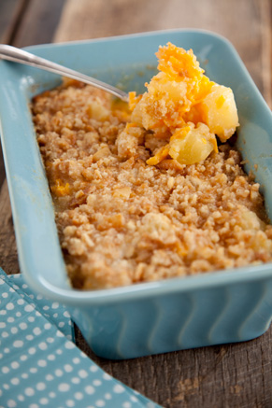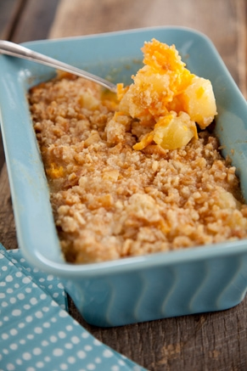

Servings: 8 servings
Prep Time: 10 min
Cook Time: 25 min
Difficulty: Easy

Ingredients
1 cup sugar
6 tablespoons all-purpose flour
2 cups grated sharp cheddar
2 (20-ounce) cans pineapple chunks, drained, and 6 tablespoons pineapple juice reserved
1 cup cracker crumbs (recommended: Ritz)
8 tablespoons (1 stick) butter, melted, plus extra for greasing pan

Directions
Preheat the oven to 350 degrees F.
Grease a medium-size casserole dish with butter.
In a large bowl, stir together the sugar and flour. Gradually stir in the cheese. Add the drained pineapple chunks, and stir until ingredients are well combined. Pour the mixture into the prepared casserole dish.
In another medium bowl, combine the cracker crumbs, melted butter, and reserved pineapple juice, stirring with a rubber spatula until evenly blended. Spread crumb mixture on top of pineapple mixture. Bake for 25 to 30 minutes, or until golden brown.

Georgia Cookie Candy
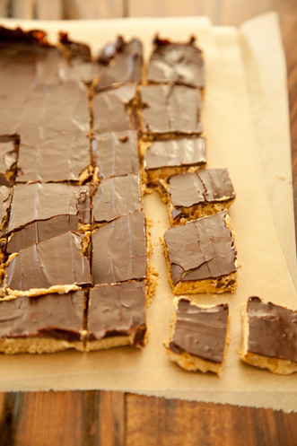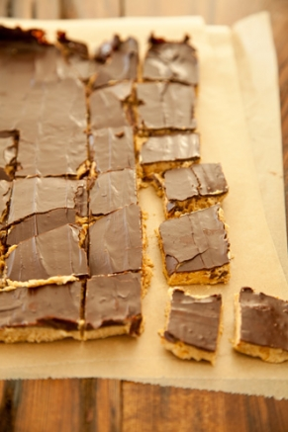

Servings: 36 to 40 pieces
Prep Time: 23 min
Difficulty: Easy

Ingredients
1 cup (2 sticks) butter or margarine, softened
1 cup crunchy peanut butter
3 cup confectioners’ sugar, sifted
1 1/2 cup graham cracker crumbs
1 1/2 cup semisweet chocolate chips

Directions
Line a 13 by 9 by 2-inch pan with foil.
Combine the butter, peanut butter, sugar, and graham cracker crumbs in a food processor. Process until the mixture forms a ball. Press into the foil-lined pan using your hands or a spatula.
Melt the chocolate chips in a double boiler over simmering water or in a microwave-safe glass dish in the microwave for 1 minute on high (100%). Stir. If the chocolate has not completely melted, microwave for 10 seconds more, then stir. Spread evenly over the cookie layer with a spatula. Chill for several hours.
When ready to serve, allow the candy to come to room temperature before cutting into pieces. Store in an airtight container in the refrigerator.
Spiced Apple Cake
TOTAL TIME: 1 hr 10 min
YIELD: 8 servings
LEVEL: Easy

INGREDIENTS
- Cooking spray
- 2/3 cup all-purpose flour
- 1/3 cup whole wheat flour
- 1 teaspoon baking powder
- 3/4 teaspoon ground cinnamon
- 1/2 teaspoon kosher salt
- 3/4 cup sugar
- 2 large eggs, at room temperature
- 1/2 cup unsweetened smooth applesauce
- 2 tablespoons unsalted butter, melted and cooled
- 1 teaspoon pure vanilla extract
- 1 medium Granny Smith apple, peeled, cored and cut into 1/2-inch pieces

Directions
Adjust an oven rack to the middle position. Preheat the oven to 350 degrees F. Spray the bottom and sides of a 9-inch round cake pan with cooking spray. Line the bottom with a round piece of parchment and spray with cooking spray again.
Combine the all-purpose flour, whole wheat flour, baking powder, cinnamon and 1/2 teaspoon salt together in a medium bowl and whisk to blend all the ingredients.
Combine the sugar and eggs in the bowl of a stand mixer fitted with a paddle attachment and beat together until light yellow, about 1 minute. Add the apple sauce, butter and vanilla and beat until combined. Add the flour in two additions and beat until incorporated. Fold in the apples and pour the batter into the prepared cake pan. Bake until a toothpick inserted into the center of the cake comes out clean, 45 to 55 minutes. Cool completely in the pan on a rack. Invert onto a serving platter. Slice and serve.

Broccoli Casserole
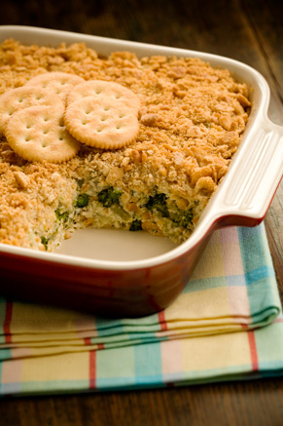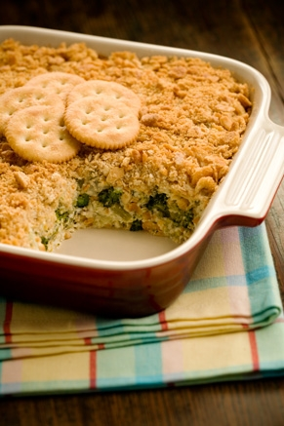

Servings: 8-10 servings
Prep Time: 10 min
Cook Time: 35 min
Difficulty: Easy

Ingredients
2 10-ounce packages frozen chopped broccoli, cooked and drained
1 cup Mayonnaise
1 cup Grated sharp cheddar cheese
1 10 3/4-ounce can condensed cream of mushroom soup
2 eggs lightly beaten
2 cup crushed Ritz crackers
2 tablespoon butter, melted

Directions
Preheat oven to 350. Spray a 13 by 9 inch baking dish with vegetable oil cooking spray. In a large mixing bowl combine, broccoli, mayo, cheese, soup and eggs. Mix well with a metal spoon. Place the mixture in the prepared baking dish. Top with the crushed crackers and pour the melted butter evenly over the crackers. Bake for 35 minutes or until set and browned.

Phyllo Wrapped Asparagus
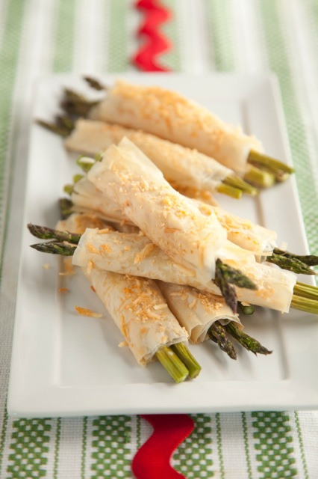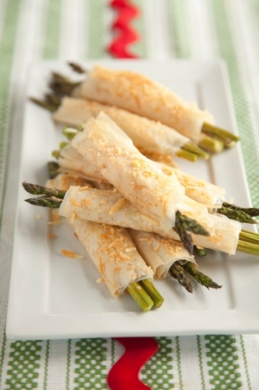

Servings: 3 to 4 servings
Prep Time: 10 min
Cook Time: 18 min
Difficulty: Easy

Ingredients
8 or 9 asparagus spears
4 sheets frozen phyllo (filo) pastry from a 16-ounce package, thawed and covered with a clean, damp tea towel
1/4 cup butter, melted
1/4 cup freshly grated Parmesan cheese

Directions
Preheat oven to 375 degrees F. Snap off tough ends of the asparagus. Unwrap the phyllo pastry and cut the stack in half lengthwise. Remove 4 sheets of pastry. Reserve the rest for another use; store in an airtight freezer bag. Cover the phyllo lightly with a damp tea towel to keep it from drying out. Take one piece of phyllo and brush lightly with melted butter. Sprinkle with cheese. Place 2 to 3 asparagus spears on short end of phyllo. Roll up, jelly-roll style. Fold over the ends to enclose the asparagus spears. Place each roll, seam side down, on a baking sheet. Brush with butter and sprinkle with cheese. Repeat until all the asparagus spears are rolled. Bake for 15 to 18 minutes, or until golden brown and crispy.
Sausage Swirls
Ingredients
Two 8-ounce cans refrigerated crescent dinner rolls
1 pound ground sausage, mild for kids, hot for adults, or sage if you prefer
Separate 1 can of dough and form into 4 rectangles. Firmly press the perforations to seal. Take the uncooked sausage and cut it into 8 chunks. Using 4 chunks of the sausage, spread each of the rectangles with a thin layer (about 1/8 inch thick). Starting at the short end, roll each rectangle tightly into a cylinder. Repeat with the other can of dough and remaining sausage. Place on a plate, cover with plastic wrap, and chill until firm, about 30 minutes, then cut each roll into 4 slices.
When ready to bake, preheat the oven to 375 deg. F. Place the sausage swirls 1/2 inch apart on ungreased baking sheets.
Bake for 18 to 20 minutes, until golden brown and the sausage is thoroughly cooked.
Makes 32 swirls.

The Best Damn Blueberry Muffin You’ll Ever Eat
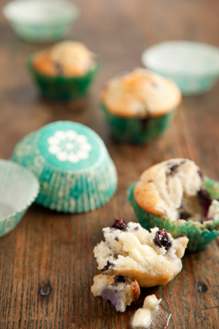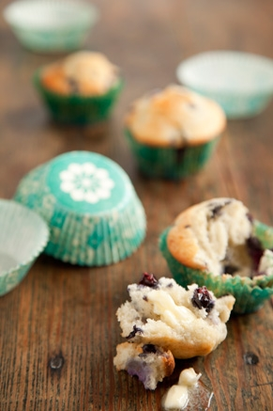

Servings: 12 muffins
Cook Time: 25 min
Difficulty: Easy

Ingredients
2 cups all-purpose flour
2 teaspoons baking powder
1/2 cup sugar
1 stick unsalted butter, melted
1 egg, slightly beaten
3/4 cup whole milk
1 1/2 cups fresh blueberries
1/2 cup granulated brown sugar or white sugar

Directions
Preheat the oven to 350 degrees F. Grease a 12-cup muffin tin.
In a bowl, combine the flour, baking powder and sugar. In another bowl, combine butter, egg, and milk and mix well. Pour the wet ingredients into the flour mixture and with a spatula, stir until just combined. Do not beat or over mix; it’s okay if there are lumps in the batter. Gently fold the blueberries into the batter.
Spoon the batter into the muffin tray, filling each cup about 2/3 full. Bake for 10 minutes and remove from the oven. Sprinkle the tops of the muffins with the granulated brown or white sugar and return the muffins to the oven to bake for an additional 10 to 20 minutes, until the tops are golden brown and a toothpick inserted into the center of a muffin comes out clean. Cool for about 10 minutes in the pan before turning the muffins out.
HOT ASPARAGUS DIP
YIELDS 3 to 4 cups
INGREDIENTS: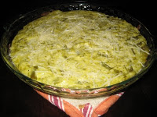
Two 12-ounce cans asparagus spears
1 1/2 cups Mayonnaise
1 1/2 cups freshly grated Parmesan cheese, plus additional for sprinkling
2 cloves garlic, shopped
Salt and Pepper to taste
Preheat the oven to 350 degrees. Drain and chop the asparagus. Add the remaining ingredients and mix; pour into baking dish. Bake for 20 to 25 minutes until slightly brown and bubbly. Remove from oven and sprinkle with additional Parmesan cheese. Serve hot with lightly toasted French bread rounds or multigrain pita chips.
SOUTH OF THE BORDER MASON-DIXON DIP
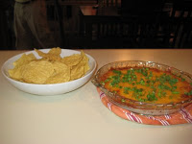Serves 6

INGREDIENTS:
One 15-ounce can chili
2 cups grated sharp Cheddar cheese
3 green onion tops, chopped
Two 8-ounce packages cream cheese, softened

DIRECTIONS:
Preheat oven to 350 degrees. Heat the chili in a saucepan over medium heat for about 5 minutes. Press the softened cream cheese into the bottom of a 1.5 quart casserole dish. Pour the heated chili over the cream cheese and sprinkle the grated cheddar over the top. Bake for 20 minutes or until it is hot and bubbly. Remove from the oven and sprinkle with the chopped green onions. Serve immediately with tortilla chips.

Almond Chicken Salad
Ingredients
- 2 tablespoons lemon juice
- 1/2 cup mayonnaise
- 1 teaspoon salt
- 3 1/2 cups diced chicken
- 1 cup finely diced celery
- 1/3 cup slivered almonds
- dried cranberries (optional)
Directions
Combine lemon juice, mayonnaise, and salt and blend well. Toss with chicken, celery and almonds. Serve on bread or crisp lettuce.

